# Data Exploration with Azure SQL Database – Customer, Account, and Loan Feeds

# 1. Setting Up Azure SQL Database

In this section, we will create an Azure SQL Database using the Azure portal. Follow the steps below to set up a new database and server.

## Step 1: Open the Azure portal to create a database and for working on it.

## Step 2: Go to the search bar for 'SQL database', and select 'Create'.

## Step 3: Basics

* a. Resource group: Create a new group named ‘resourcegrp1’.
* b. Database name: Enter ‘db1’.
* c. Server: Create a new server with the following details:
* - Server name: “dbserver1”.
* - Location: 'Central US'.
* - Authentication method: Select 'SQL Authentication'.
* - Server admin login: Enter 'bellamkonda'.
* - Password: Enter a secure password.
* - Confirm Password: Re-enter the password, then select 'OK'.
* d. Back to the Basics page:
* - Want to use SQL elastic pool?: Select 'No'.
* - Workload environment: Choose 'Production'.
* - Compute + storage: Select 'Configure database'.
* - Service tier: Select 'Basic (for less demanding workloads)', then click 'Apply'.
* - Backup storage redundancy: Choose 'Locally-redundant backup storage'.

## Step 4: Networking

* a. Connectivity method: Select 'Public Endpoint'.
* b. Allow Azure services and resources to access this server: Choose 'Yes'.
* c. Add current client IP address: Select 'Yes'.
* d. Connection policy: Choose 'Default'.
* - Uses Redirect policy for all client connections originating inside of Azure (except Private Endpoint connections) and Proxy for all client connections originating outside Azure.

## Step 5: Security

* No changes needed - keep the default settings.

## Step 6: Additional Settings

* a. Use existing data: Select 'Sample'.

## Step 7: Tags

* No changes needed - keep the default settings.

## Step 8: Review + Create

* a. Review your settings, then select 'Create'.

Congratulations! You just created a Database in Azure Portal.

Now go to Query Editor to perform some basic operations like Creating, Inserting and Querying in database.

## Step 2: Data Organization

Here, in this step we organize data by creating tables as per our requirement.

#### Table 1: - Customer Feed:

CREATE TABLE customers (  
 customer_id INT PRIMARY KEY,  
 first_name VARCHAR(50),  
 last_name VARCHAR(50),  
 address VARCHAR(100),  
 city VARCHAR(50),  
 state VARCHAR(50),  
 zip VARCHAR(20)  
);

#### Table 2: - Account Feed:

CREATE TABLE accounts (  
 account_id INT PRIMARY KEY,  
 customer_id INT,  
 account_type VARCHAR(50),  
 balance DECIMAL(10, 2),  
 FOREIGN KEY (customer_id) REFERENCES customers(customer_id)  
);

#### Table 3: - Transaction Feed:

CREATE TABLE transactions (  
 transaction_id INT PRIMARY KEY,  
 account_id INT,  
 transaction_date DATE,  
 transaction_amount DECIMAL(10, 2),  
 transaction_type VARCHAR(50),  
 FOREIGN KEY (account_id) REFERENCES accounts(account_id)  
);

#### Table 4: - Loan Feed:

CREATE TABLE loans (  
 loan_id INT PRIMARY KEY,  
 customer_id INT,  
 loan_amount DECIMAL(10, 2),  
 interest_rate DECIMAL(5, 2),  
 loan_term INT,  
 FOREIGN KEY (customer_id) REFERENCES customers(customer_id)  
);

#### Table 5: - Loan Payment Feed:

CREATE TABLE loan_payments (  
 payment_id INT PRIMARY KEY,  
 loan_id INT,  
 payment_date DATE,  
 payment_amount DECIMAL(10, 2),  
 FOREIGN KEY (loan_id) REFERENCES loans(loan_id)  
);

## Step 3: Data Insertion

* Populate tables with sample data using `INSERT INTO` statements for each table.
* Ensure data consistency and relationships, ensuring each foreign key points to valid primary keys.
* Historical Data is available in many open resources like Kaggle. By using that we can populate the data to our tables.

**Insert into customers Table:**

INSERT INTO customers (customer_id, first_name, last_name, address, city, state, zip) VALUES

(1, 'Rajesh', 'Sharma', '123 MG Road', 'Mumbai', 'Maharashtra', '400001'),

(2, 'Anjali', 'Verma', '456 Sector 5', 'Gurgaon', 'Haryana', '122001'),

(3, 'Ravi', 'Kumar', '789 Green Park', 'Delhi', 'Delhi', '110016'),

(4, 'Priya', 'Mehta', '321 Ring Road', 'Ahmedabad', 'Gujarat', '380001'),

(5, 'Arjun', 'Desai', '654 Hill View', 'Bangalore', 'Karnataka', '560001'),

(6, 'Sneha', 'Gupta', '111 Park Street', 'Kolkata', 'West Bengal', '700001'),

(7, 'Mohan', 'Reddy', '222 Jubilee Hills', 'Hyderabad', 'Telangana', '500033'),

(8, 'Neha', 'Patel', '333 SG Highway', 'Surat', 'Gujarat', '395007'),

(9, 'Karan', 'Malhotra', '444 Marine Drive', 'Mumbai', 'Maharashtra', '400002'),

(10, 'Aditi', 'Nair', '555 Palm Beach Road', 'Navi Mumbai', 'Maharashtra', '400703');

**Insert into accounts Table:**

INSERT INTO accounts (account_id, customer_id, account_type, balance) VALUES

(1, 1, 'Savings', 50000.00),

(2, 2, 'Current', 150000.00),

(3, 3, 'Savings', 75000.00),

(4, 4, 'Current', 50000.00),

(5, 5, 'Savings', 200000.00),

(6, 6, 'Savings', 100000.00),

(7, 7, 'Current', 30000.00),

(8, 8, 'Savings', 120000.00),

(9, 9, 'Current', 95000.00),

(10, 10, 'Savings', 80000.00);

**Insert into transactions Table:**

INSERT INTO transactions (transaction_id, account_id, transaction_date, transaction_amount, transaction_type) VALUES

(1, 1, '2024-03-01', 5000.00, 'Credit'),

(2, 2, '2024-09-02', 20000.00, 'Debit'),

(3, 3, '2024-09-03', 10000.00, 'Credit'),

(4, 4, '2024-03-04', 5000.00, 'Debit'),

(5, 5, '2024-09-05', 50000.00, 'Credit'),

(6, 6, '2024-09-06', 20000.00, 'Debit'),

(7, 7, '2024-09-07', 1000.00, 'Credit'),

(8, 8, '2024-09-08', 30000.00, 'Debit'),

(9, 9, '2024-09-09', 5000.00, 'Credit'),

(10, 10, '2024-09-10', 10000.00, 'Debit');

**Insert into loans Table:**

INSERT INTO loans (loan_id, customer_id, loan_amount, interest_rate, loan_term) VALUES

(1, 1, 100000.00, 8.5, 60),

(2, 2, 200000.00, 9.0, 72),

(3, 3, 150000.00, 8.0, 48),

(4, 4, 250000.00, 7.5, 84),

(5, 5, 300000.00, 9.2, 60),

(6, 6, 120000.00, 8.8, 36),

(7, 7, 180000.00, 7.9, 48),

(8, 8, 220000.00, 9.1, 60),

(9, 9, 160000.00, 8.3, 72),

(10, 10, 190000.00, 8.6, 60);

**Insert into loan_payments Table:**

INSERT INTO loan_payments (payment_id, loan_id, payment_date, payment_amount) VALUES

(1, 1, '2024-09-11', 2000.00),

(2, 2, '2024-09-12', 3000.00),

(3, 3, '2024-09-13', 2500.00),

(4, 4, '2024-09-14', 4000.00),

(5, 5, '2024-09-15', 5000.00),

(6, 6, '2024-09-16', 1500.00),

(7, 7, '2024-09-17', 2200.00),

(8, 8, '2024-09-18', 3500.00),

(9, 9, '2024-09-19', 2800.00),

(10, 10, '2024-09-20', 3000.00);

Now we are inserted some sample data successfully into the tables we are created as per the screenshots.

# Step 4: Data Exploration

4.1Write query to retrieve all customer information:

select * from Customers;

4.2: Query accounts for a specific customer:

select * from accounts where customer_id=5;

4.3: Find the customer name and account balance for each account

select concat(first_name,' ',last_name) as customer_name,a.account_type, balance

 from customers c join accounts a on c.customer_id=a.customer_id ;

4.4: Analyze customer loan balances:

select concat(first_name,' ',last_name) as customer_name,l.loan_amount

 from customers c join loans l on c.customer_id=l.customer_id ;

4.5: List all customers who have made a transaction in the 2024-03

select distinct concat(first_name, last_name) as customername , transaction_date

from customers c

join accounts a on   c.customer_id=a.customer_id

join transactions t on a.account_id=t.account_id

    where t.transaction_date between '2024-03-01' and '2024-03-31';

## Step 5:  Aggregation and Insights

5.1: Calculate the total balance across all accounts for each customer:

SELECT concat(first_name, last_name) as customername , SUM(a.balance) AS total_balance

FROM customers c

JOIN accounts a ON c.customer_id = a.customer_id

GROUP BY c.customer_id, c.first_name, c.last_name;

5.2: Calculate the average loan amount for each loan term:

SELECT loan_term, AVG(loan_amount) AS average_loan_amount

FROM loans

GROUP BY loan_term;

5.3: Find the total loan amount and interest across all loans:

 SELECT SUM(loan_amount) AS total_loan_amount, SUM(loan_amount * (interest_rate / 100)) AS total_interest FROM loans;

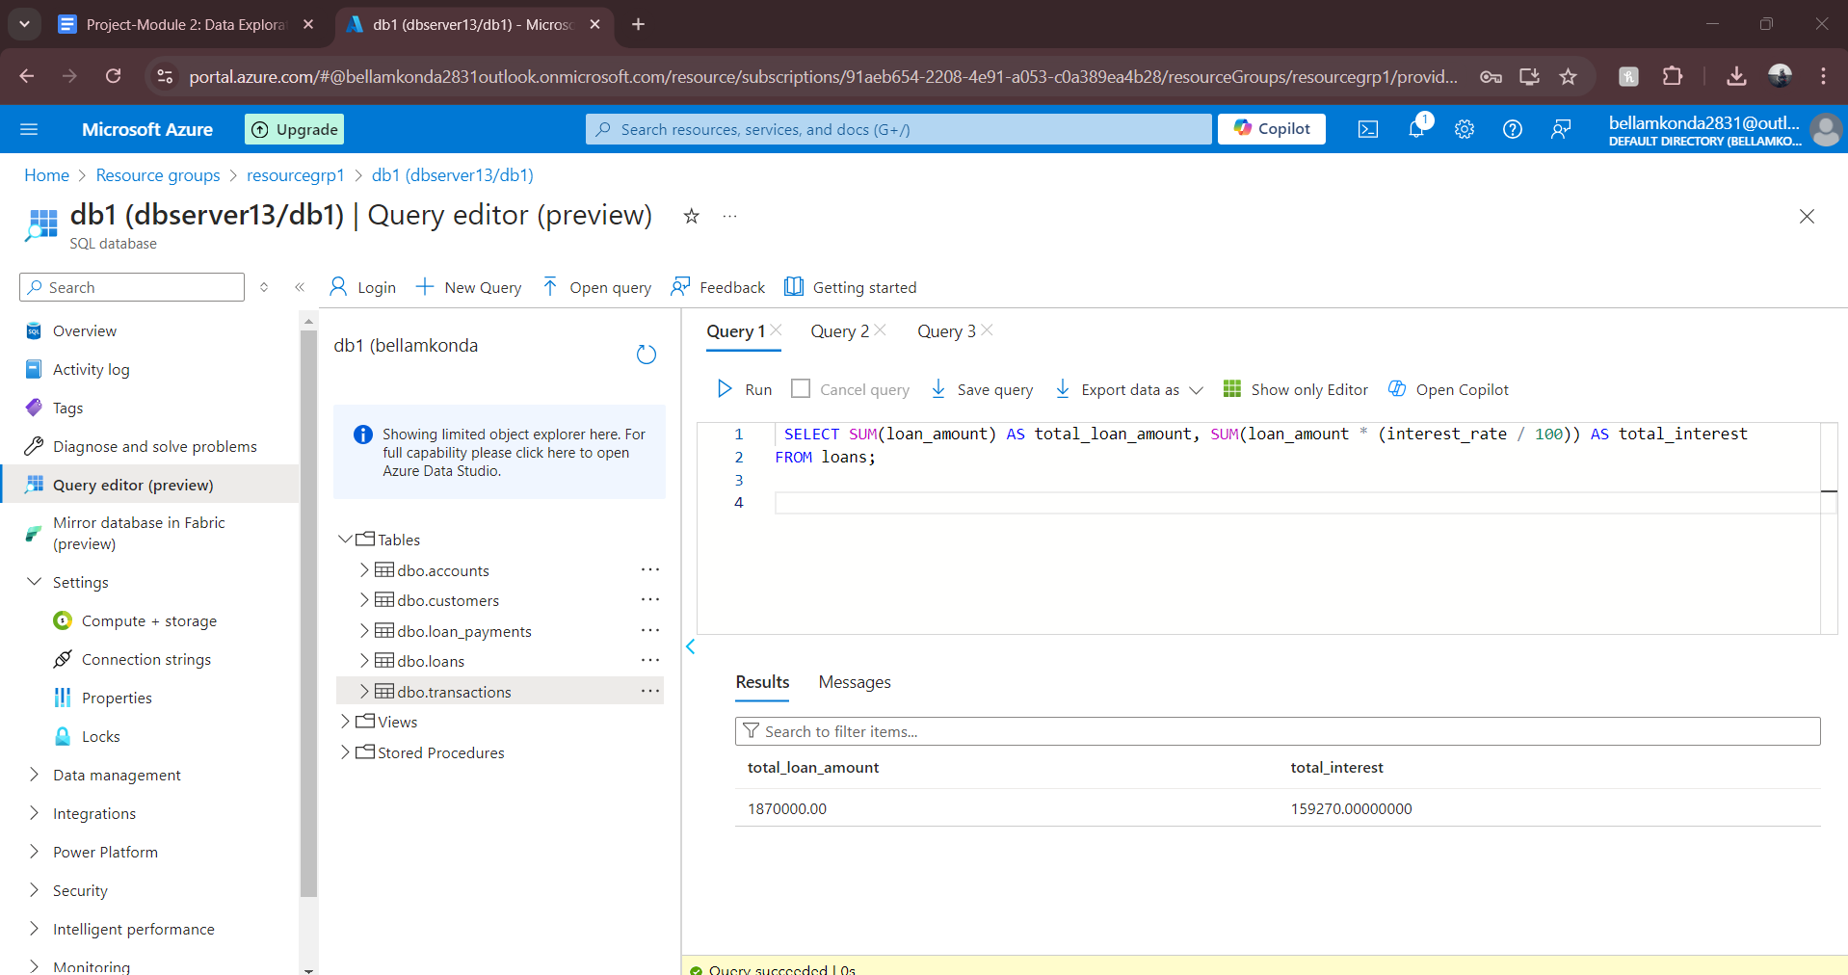

5.4: Find the most frequent transaction type

SELECT transaction_type, COUNT(*) AS count

FROM transactions

GROUP BY transaction_type

ORDER BY count DESC;

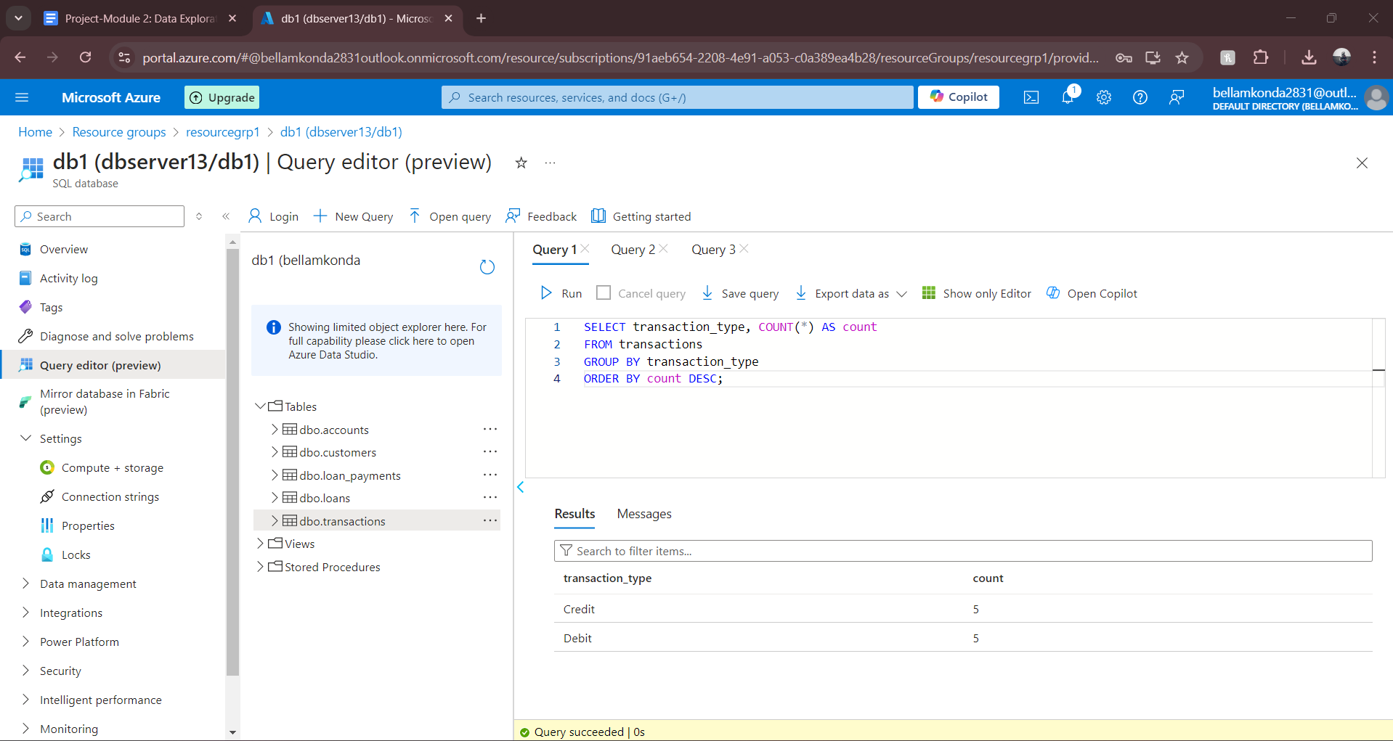

5.5: Analyze transactions by account and transaction type:

SELECT account_id, transaction_type, COUNT(*) AS transaction_count, SUM(transaction_amount) AS total_amount

FROM transactions

GROUP BY account_id, transaction_type;

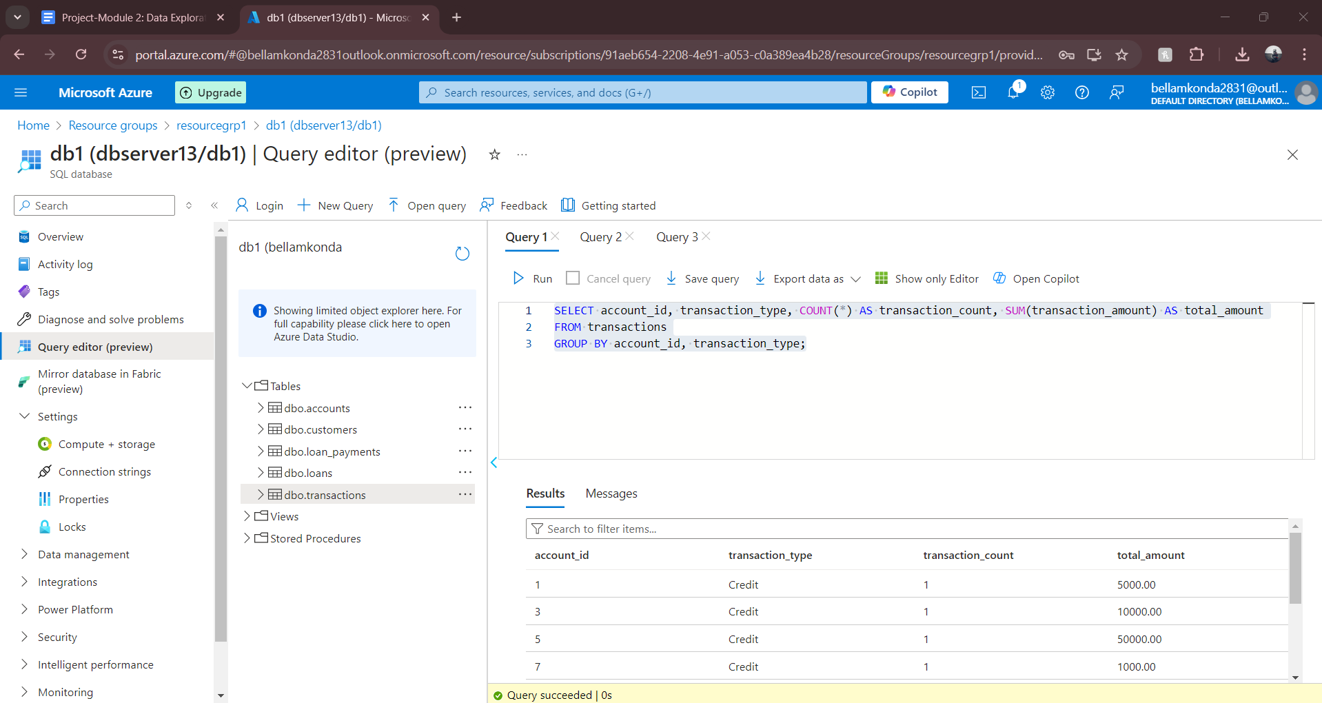

## Step 6: Advanced Analysis

6.1: Create a view of active loans with payments greater than $1000:

CREATE VIEW active_loans_with_high_payments AS

SELECT l.loan_id, c.first_name, c.last_name, l.loan_amount, lp.payment_amount

FROM loans l

JOIN customers c ON l.customer_id = c.customer_id

JOIN loan_payments lp ON l.loan_id = lp.loan_id

WHERE lp.payment_amount > 1000;

   6.2: Create an index on `transaction_date` in the `transactions` table for performance optimization:

CREATE INDEX idx_transaction_date ON transactions(transaction_date);

**************************************************************************** END OF PROJECT*************************************************************************